Universal Process Notation Documents (UPNs) are extremely useful tools for documenting, training and supporting software implementations. Compared to other types of flow charts, UPNs are universally easy to create and follow. They focus on business process activities, inputs, outputs, resources and systems all while using 1 shape—the activity box. They can be easily made in PowerPoint by modifying an existing template.

The basic rules of UPN are as follows:

* They read from left to right.
* There should be no more than 8-10 activity boxes on one screen.
* Drill down from an activity box to a lower level to describe the detail.
* Attach supporting information to an activity box.
* View and edit should be controlled by access rights.
* Version control and history of changes should be shown at a diagram level.

# Creating a UPN:

**Step 1:** Open a Template UPN Document

**Step 2:** Name Your UPN & Identify First Activity in Business Process

* This should start with an *Action* word.
* Be Specific

**Step 3:** Identify Who is Responsible for First Activity

* Do: Identify a Job Title or Role
* Don’t: Identify a Particular Resource/Someone’s Name

**Step 4:** Identify What System(s) is Relevant for First Activity

* Say which tool or program, specifically, that is needed to complete this activity.

**Step 5:** Identify Input(s) Required for First Activity

* What needs to be true for the activity to take place?
* Inputs *already* *exist*, they should be in past tense.

**Step 6:** Identify Output(s) Generated by First Activity

* What was completed as a result of the first activity?

**Step 7:** Repeat Steps Until Entire Business Process is Mapped Out in 8-10 Steps

* Add more activity boxes if needed by copying and pasting, but no more than 8-10.

**Step 8:** Determine if Any Activities Require a Drill Down to Map Out Sub-Processes

* Create UPN on Another Slide Detailing Sub-Process
* For Additional Clarification, You Can Change the Outline of the Last Activity Box to Green Indicate the Final Step.

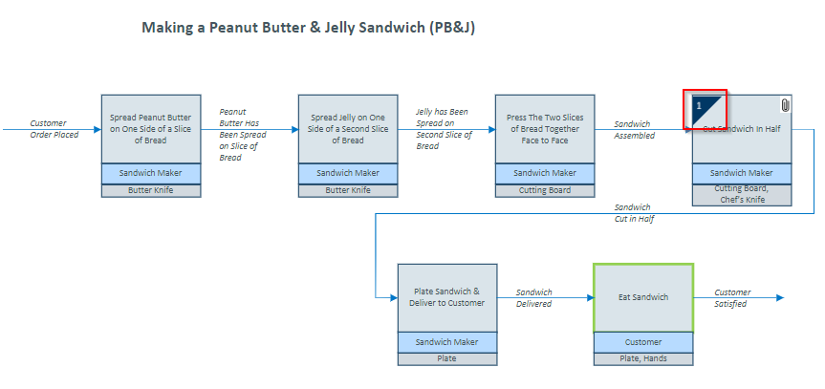

**Step 9:** Determine if Any Activities Require an Attachment that Would Help Display How a Particular Activity Looks or Functions

* Attach Document Via a Link to That Document in Teams, SharePoint, Laserfiche, etc.

**End Procedure**